**The artificial intelligence**

Links:

* index.html
* how does the filed had begun.html
* problems of AI.html
* artificial intelligence importance, types and most importance apps.html

Source Code:

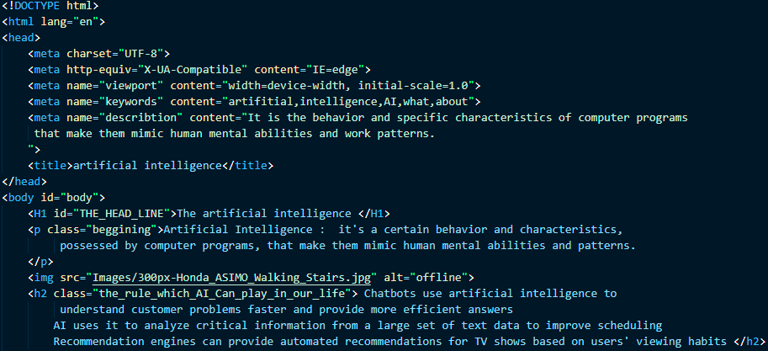

Name: Mohamed Ahmed Ismail Mahmoud

Section: 29

I.D: 642

GitHub Link: <https://github.com/moesmail2002/html-project>

GitHub Pages Link: <https://moesmail2002.github.io/html-project/>